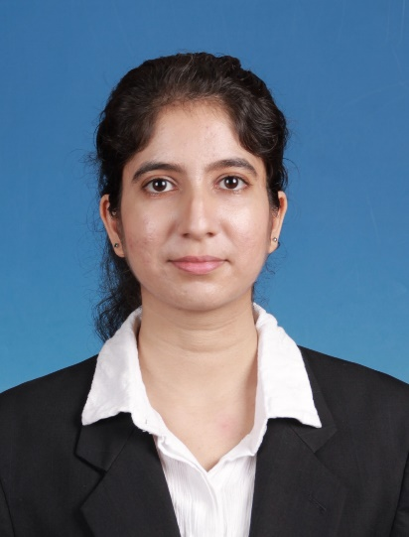**Jasminder Kaur A/P Sadu Singh**

Address : No 12, Regat Labrooy, Taman Merdeka,

30100 Ipoh, Perak.

Contact : 017-5137195

Email address : [jasminkim22@gmail.com](mailto:jasminkim22@gmail.com)

Date of birth : 22/03/1994

**Career Aim**

To begin my career by being a part of a leading group to hone my financial and investment skills and to pave a career for myself in this path while developing a strong business acumen. I have a strong desire for a challenging career which will broaden my analytical, critical thinking and problem solving skills.

**Educational Background**

University of Malaya (2013- 2016)

Bachelor of Economics and Administration

Anticipated Graduation Date : October 2017

CGPA : 3.28

Perak Matriculation College (2012-2013)

CGPA : 4.00

MUET : Band 4 (2013)

Sekolah Menengah Tarcisian Convent, Ipoh (2007-2011)

SPM : 8A+, 1A. 1A-

PMR : 8A

**Co-curricular Experiences**

Corporate Relations Member of AIESEC (2013/2014)

Sponsorship Member of Kebajikan Anak Yatim (KEBATIM), 2013/2014

Participant of Indian Dance Competition in Festival Kesenian Universiti Malaya (FESENI), 2014

Malaysian National Chemistry Quiz (Merit), 2011

Publicity Director of Interact Club, 2011

Australian National Chemistry Quiz (Distinction), 2011

Anugerah Program Permata for Additional Mathematics (school level), 2011

Treasurer of secondary class, 2010-2011

Treasurer of secondary school Choir Society, 2009-2011

Represented secondary school in national level choir competition, 2009

Secondary School Assembly Pianist, 2007-2011

**Work Experience**

**Internship**

Sept 2016 – Dec 2016

Tamil Selvi Agency @Zurich Insurance Malaysia Berhad (Ipoh Branch)

**Skills**

Excellent command in English, Bahasa Melayu and Punjabi (SPM, A-)

Speaks fluently in Hindi

Proficient in Mandarin Level 1, 2015

Proficient in Microsoft Excel 2013 (Business Computing Course, B+), Microsoft Word and Powerpoint

Advanced in SPSS (Version 22.0)

Intermediate in EViews 9

ABRSM Piano (Theory Grade 7, Practical Grade 5)

**Interests/Hobby**

Reading books, hiking, dancing, baking.

**References**

Dr Yong Sook Lu

Senior Lecturer,

Department of Economics,

Faculty of Economics and Administration,

University of Malaya  
Tel: [+603 7967 3717](tel:%2B603%207967%203717)

Dr Santha Chenayah Ramu,

Senior Lecturer,

Department of Economics,

Faculty of Economics and Administration,

University of Malaya

Tel: +6037967 3733